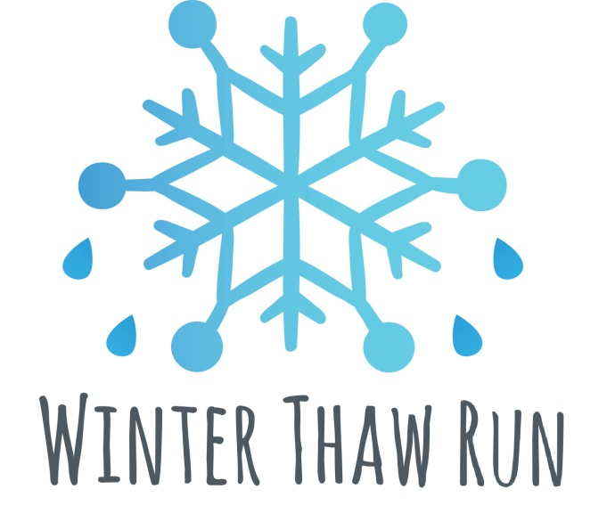

Hosted by: Penn State Club Cross Country

Winter Thaw Run
Saturday, February 25, 2017
Run: 10:30 am /Awards: to follow
IST Bridge, Penn State University Campus

SPONSORED BY
Freeze Thaw Cycles, KIND Bar and Rapid Transit Sports

Awards
Awards given to Top 5 M/F

Last Name: First Name: Sex: Male / Female (circle one) Age (on race day): Birthdate: Mailing Address: City: State: Zip Code: Phone: ( _) - Email: Emergency Contact Name: Phone ( ) - _ Registration fee is $10.00. Registration fee for this event may be paid using cash, check, or money order. Payment Information: Make check or money order payable to “Penn State Club Cross Country” Registration forms and fees can be dropped off at 142 White Building prior to race day.
Release of Liability
In consideration for being permitted to participate in this Thaw 5k, which is sponsored by Club Cross Country and takes place on the premises of The Pennsylvania State University, I (or if under 18 my parent or legal guardian) hereby release and hold harmless the Club Cross Country, and The Pennsylvania State University their trustees, officers, employees, members, volunteers and representatives from any and all liability resulting from my participation in this event. By my signature below, I hereby acknowledge that I am at least 18 years of age or this has been signed or countersigned by my parent or legal guardian.

Printed Name Signature & Date

If under 18, Printed Name of Parent/Legal Guardian Parent/Legal Guardian Signature & Date

To be completed by race staff:
Participant # Registration fee of $10.00 paid on Staff initials:

