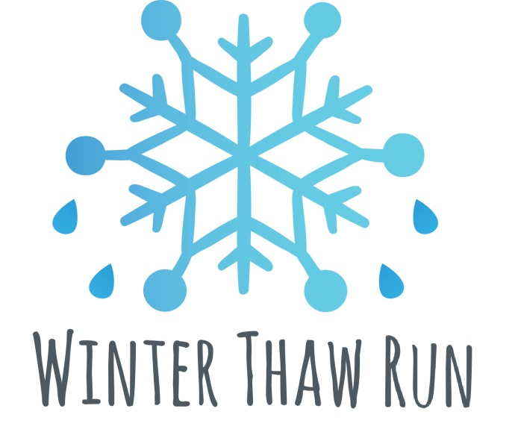

Hosted by: Penn State Club Cross Country and Health Promotion and Wellness

Winter Thaw Run
Saturday, February 23, 2019
Run: 10:00 am /Awards: Approx. 11:00 am
Pollock and Burrowes Road,
Penn State University

SPONSORED BY
KIND Bar and Rapid Transit Sports

Awards
Awards given to Top 10 Male and Female Finishers

Last Name: First Name: Sex: Male / Female (circle one) Age (on race day): Birthdate: Mailing Address: City: State: Zip Code: Phone: ( _) - Email: Emergency Contact Name: Phone ( ) - _
Registration fee is $10.00 (2/18-2/22), and $15 (2/23/19). Registration fee for this event may be paid using cash, check, or money order. Payment Information: Make check or money order payable to “Penn State Club Cross Country”

To be completed by race staff:

Participant # Registration fee of $ paid on Staff initials:

